Making Choices for Archaeological Archives
A survey of archive selection practice in Europe

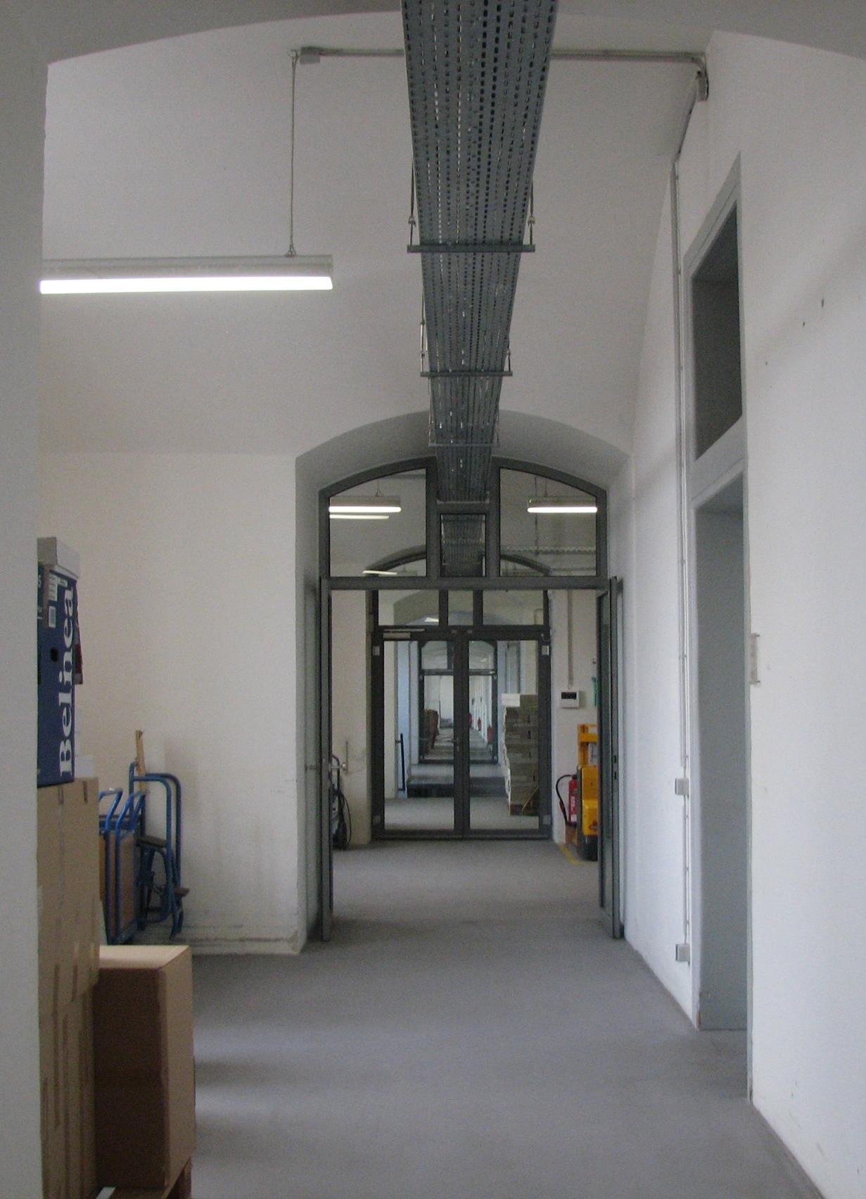

Duncan Brown
EAC Working Group for Archaeological Archives
Contents

- Introduction 3
- Recommendations 3
- The Survey 4
  - Background 4
  - Method 5
  - Response to the survey 5
- Results from the Survey 6
  - Survey Section 1: Ownership 6
  - Survey Section 2: Copyright 10
  - Survey Section 3: Storage conventions 11
  - Survey Section 4: Rationale for selection 15
  - Survey Section 5: Selection methodology 19
  - Survey Section 6: Sustainability 30
  - Survey Final Section: Comments 31
- Bibliography 32
Appendix Report on archaeological selection procedures in Poland – a case study

- Introduction
A recent initiative of the EAC is “Dare to Choose: Making Choices in Archaeological Heritage Management” (Making Choices 2018). This theme resonates with the EAC Working Group for Archaeological Archives (EACWGAA), whose members have been considering the subject of selection for archaeological archiving (both finds and documentation) for some time. Our aim is to assist practitioners by producing ancillary guidance to the ARCHES publication “A Standard and Guide to Best Practice in Archaeological Archiving in Europe” (Perrin et al. 2014).
​Selecting for archaeological archives has been much discussed in recent years, due mainly to the pressure on storage space at archive repositories that has arisen from increasing archaeological activity. That problem has been well researched in England, where successive surveys have concluded that, due to a lack of storage space, within ten years 112 out of 154 local institutions that currently collect archaeological archives will be unable to accept more material (Boyle et al. 2016, 2017, and 2018). Although this problem is more to do with economics and infrastructure than archaeology it is very real and must be taken into account in terms of how we practice archaeology. It is important that archaeologists are not drawn into debates on finances, where they may have little influence, but instead establish an archaeological approach to alleviate this problem.
It is generally understood that one way of easing pressure on storage space is to produce archaeological archives to a standard that ensures they contain only those records and finds that have the potential to inform future use, whether that be for display, education, research or enjoyment. Developing and carrying out a selection strategy during the course of an archaeological project will ensure that the archive has that potential and therefore, by definition, justifies long term curation thereafter.
As their contribution to the ‘Making Choices’ debate the EACWGAA undertook a survey of archive selection practice in EAC member states. This has revealed much variation in the ways selection is defined, managed and documented and the EACWGAA has therefore formulated several recommendations to enable a more consistent approach to selection across Europe. Those recommendations are presented here, in advance of the results of the survey.
- Recommendations
Based on the results of the survey, including the Polish case study, there is a clear need to develop and emphasise the section on selection in “A Standard and Guide to Best Practice in Archaeological Archiving in Europe” (Perrin et al. 2014) and produce further guidance. This should include the following:
1. Acknowledgment of selection as an inherent element of archaeological practice and archive production.
2. An agreed and concise definition of selection.
3. A comprehensive consideration of the rationale for selection which cites scientific, archaeological reasons over economic drivers.
4. A full description of the selection process, including the creation, development and application of selection strategies and procedures for disposing of deselected material.
5. Definition of the appropriate scope of selection strategies, referring to the research aim and objectives of an archaeological project and the stages through which it will progress, from planning to archive transfer.
6. A list of all stakeholders involved in developing, monitoring and executing the selection process for an archaeology project, with a description of their individual roles and the mechanisms for ensuring best practice is followed.
7. Guidelines for the documentation of the selection process and inclusion in the documentary archive.
8. Provision of a selection strategy checklist.
9. Discussion of the need to resolve issues of copyright to documents and data, as well as ownership of material objects, as part of the selection and disposal process.
10. Guidelines for the selection and curation of digital archaeological archive material.
The latter requires a much closer look, and it seems at this stage that it should be approached in detail separately. Initial ancillary guidelines could therefore highlight the statements from EAC Guidelines 1 (Perrin et al. 2014) and, recognizing the reality for many European countries, describe possible approaches to this issue in the absence of Trusted Digital Repositories.
A new Selection Toolkit produced in England by the Chartered Institute for Archaeologists, in conjunction with Historic England (http://cifa.heritech.net/selection-toolkit), might be a good starting point for stimulating discussion on the international level.
Comparison of the general results with the case study has revealed several specifically Polish issues. It is almost certain that reports for other countries would show similar effects. The future guidance should therefore address selection issues with regard to the diversity identified in the study.
- The Survey
  - Background
The ARCHES Standard states that “…a clear strategy for what documentary and material (finds) archive elements are to be selected for retention should be both understood and implemented by the project team and its use monitored by the project manager. The selection and retention strategy should be flexible and open to amendment; for example the discovery of unexpected finds or stratigraphy may affect the decision about what was previously identified for dispersal.” (Perrin et al. 2014, 25)
Selection is governed by legal, academic and pragmatic regulations and conventions that vary considerably across Europe and it was therefore decided that the next step for the EACWGAA with regards to the Making Choices initiative would be to conduct a survey of selection practice. The survey was intended to gather information on how selection is determined, managed and regulated within individual European states, with the aim of gathering information on criteria for selection, the legal frameworks within which selection can take place and the ways in which selection is incorporated into archaeological projects. The questionnaire is seen as a means of collecting all that information in a systematic way that will facilitate analysis and go on to assist the compilation of guidance.

Although the criteria governing selection will not always be the same for every project, there are some fundamental principles that should remain consistent. It is intended that EAC Guidance produced by the Working Group will establish those principles and promote them internationally.

  - Method
A survey questionnaire was formulated by the EACWGAA and sent to all EAC members. The aim was to establish how selection is perceived in different states and how selection procedures are determined, managed and concluded.
The questionnaire was framed around the five subject areas shown below.
Subject | Related issues
Ownership | is it legally permissible to dispose of material?
Storage conventions | what types of stores curate archaeological archives?
 | how is it decided which stores will collect an archive?
Rationale for selection | what are the reasons for selection?
 | how are selection strategies developed (if at all)?
Selection methodologies | who is involved in developing a selection strategy?
 | how is the selection strategy developed?
 | how is the selection strategy carried out?
Sustainability | has there been research into the results of selection?

  - Responses to the survey
There are thirty member countries of the EAC and the named contacts for each of those were sent an invitation to complete the questionnaire on-line. Further invitations were sent to various representatives of separate states or cantons in federal countries such as Germany and Switzerland, as well as various organisations storing archaeological archives in Poland, bringing the total number of invitations to 127. The responses to the survey from central, state or cantonal institutions totalled 24.
An additional eleven responses were gathered in Poland, where individual collecting institutions and other archaeological organisations were sent the questionnaire in an attempt to survey selection practice across the whole country, where there may be differences according to varying priorities. This is discussed in the case study that follows this general report on the overall survey results.

- Results from the Survey
The questionnaire was split into five sections around the subjects shown above, within which there is a total of 24 individual questions. Not all the respondents could answer every question. In some places selection does not happen at all and much of the questionnaire was therefore largely unanswerable, but even so, it is useful to include those states within the survey.
  - Survey Section 1: Ownership
Three questions were asked in relation to ownership, with the intention of establishing the legal issues surrounding the selection, or perhaps more pertinently the de-selection, of archaeological materials. In countries where archaeological objects belong to the land-owner, mechanisms for the transfer of ownership have to be in place before deselected objects can be disposed of, whereas the process might be more straightforward if the material is owned by the state or other authority.
Ownership also relates to how the selection process is planned, because the selection procedure might be more embedded in a project if the finds are understood to be in the ownership of the state from the outset. The same is true of the final transfer of archaeological materials into curatorial care.

Q 1.1 How is ownership of archaeological material resolved?

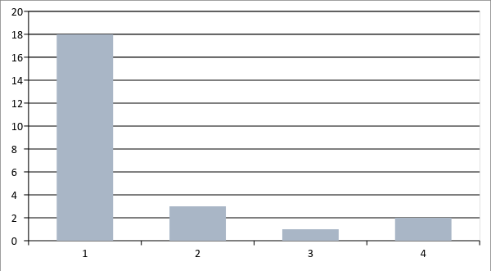

1 | All archaeological objects are automatically owned by the state and transferred to a selected repository
2 | All archaeological objects are owned by the landowner, who is expected to transfer title to the archive repository
3 | Ownership is shared between the landowner and the finder
4 | Title to archaeological material is never considered and everything just goes to the repository
For a large majority of respondents archaeological objects are automatically owned by the state. In three instances they belong to the land-owner, who is expected to transfer title to a third party before selection can take place. There is one case where ownership is shared while in a further two, there is no consideration of ownership at all.
It is much more straightforward to carry out selection on material that is owned by the state from the moment it is recovered, because deselected objects do not have to be returned to a different owner. On the other hand, there may be less inclination to carry out any selection for archive at all because it may be less likely that archive deposition costs will be imposed (see below).

Q 1.2 During the course of a project when is transfer of title usually agreed in principle?

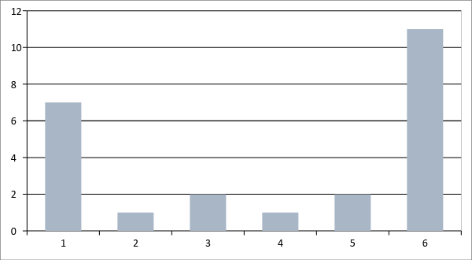

1 | Project planning
2 | Data-gathering
3 | Assessment / analysis (post-fieldwork)
4 | Archive compilation
5 | At the point of archive transfer
6 | No response
Where finds are automatically owned by the state, no transfer of title is required, which explains the high number of no responses to this question. It is also true that where the state assumes ownership, it is automatically built into the project plan. In the three instances where ownership resides with the landowner, agreement of transfer of title takes place in project planning, after assessment and during archive compilation, so there is no pattern there at all. The variety of responses overall indicates that there is no generally accepted approach to transfer of title.

Q 1.3 During the course of a project, when is transfer of title signed off?
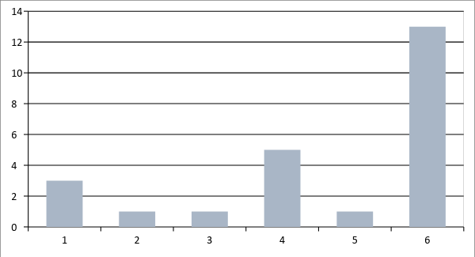

1 | Project planning
2 | Data-gathering
3 | Assessment / analysis (post-fieldwork)
4 | At the point of archive transfer
5 | Other (please specify)
6 | No response
Once again, where ownership is with the state, title to the material can easily be settled during project planning. The next most common stage is at the point of transferring the archive to the curating institution. The response classed as ‘Other’ relates to slightly more complicated sign-off procedures where the state owns archaeological material that is subsequently passed to a regional museum.

  - Survey Section 2: Copyright
Q 2.1 How is copyright to documentary archive material resolved?
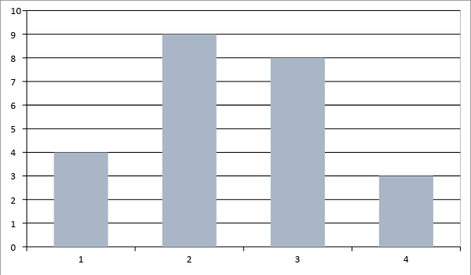

1 | The creators of the records retain copyright and issue a licence to the repository
2 | The creators of the records transfer all copyright to the repository
3 | Copyright is never considered and everything goes to the repository with no formal documented transfer procedure
4 | Other (please specify)
Copyright seems to be a less straightforward issue than title and there are a variety of situations shown here. In many cases, copyright is not even considered. Where the answer is ‘other’ copyright is determined by more than one mechanism, depending on who commissions the project.

  - Survey Section 3: Storage conventions
Q 3.1.1 Where is the documentary archive curated?
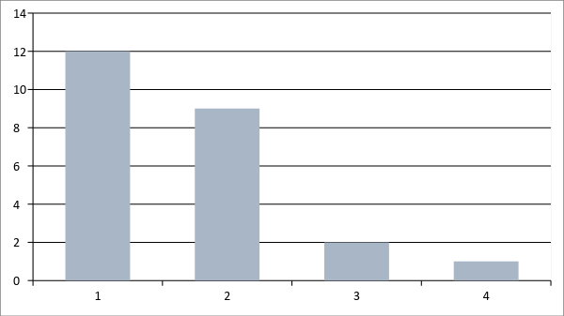

1 | Central (state) repository
2 | Regional (state) repository
3 | Central and regional repositories
4 | University
In every case but one, repositories are funded by the state and arrangements for the curation of the documentary archive seem much more straightforward than they are for the material archive (see below 3.1.4). It may also be true, however, that selection of the documentary archive is usually a much less complicated task to undertake.

Q 3.1.2 Where is the digital material curated?
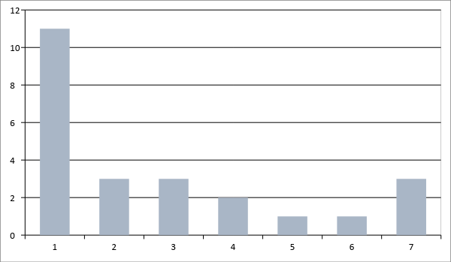

1 | Central (state) archaeology repository
2 | Central (state) digital archive facility
7 | Other
5 | Publicly funded local museum / archaeology repository
3 | Regional (state) archaeology repository
4 | Regional (state) documentary archive facility
6 | University
There is a lot of variability in the way digital material is curated and this is worrying. The EAC Standard states clearly that the digital archive must be curated by a Trusted Digital Repository (Perrin et al. 2014, 23, 26) and very few of the repositories listed here have that status. In only three cases is a digital archive facility utilised. It follows that there is probably a concomitant variability in how data management and selection procedures are developed and followed, and the digital archive may therefore be much less organised than its analogue documentary counterpart. There also often seems to be variability in what digital files are selected for the archive. In many cases it is considered sufficient to select reports but not the data from which they are derived. The EAC Standard requires all born digital material to be considered for archive (Perrin et al. 2014, 22) but that does not always happen and the potential value of the archive is therefore compromised (see Recommendation 10 above).

Q 3.1.3 In the case of born digital material, is a complete analogue copy also produced and curated?
Yes | 9 | 37.5%
No | 15 | 62.5%
The requirement to produce an analogue copy of the digital archive is perhaps a consequence of not using a Trusted Digital Repository. That, of course, does not make the information any more secure but it is a reflection of uncertainty about the nature of digital data and a notion that it has to be made secure. Where neither a printed copy nor a TDR are required the opposite is not necessarily true but the consequences of not curating digital material to required standards could be drastic.

Q 3.1.4 Where is the material archive curated?
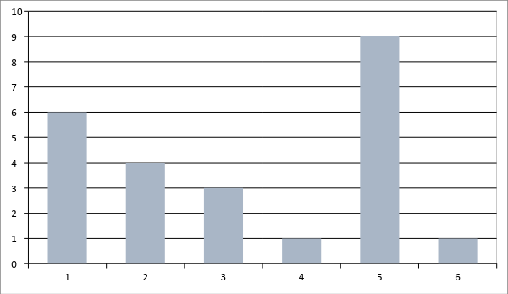

1 | Central (state) archaeology repository
2 | Regional (state) archaeology repository
3 | Regional (state) documentary archive facility and archaeology repository
4 | Publicly funded local museum / archaeology repository
5 | Multiple types of repository
6 | There is no defined system of storage
No obvious pattern can be discerned among these responses but it is clear that publicly funded storage is preferred and those are the types described among the ‘multiple’ options. That makes sense where ownership is automatically assigned to the state but it is also perhaps a reflection of the difficulties in making material assemblages secure and accessible. This seems, furthermore, not a profitable venture to undertake because there is no obvious interest from the private sector.
Q 3.2 How is it determined which repository will collect an archaeological archive?
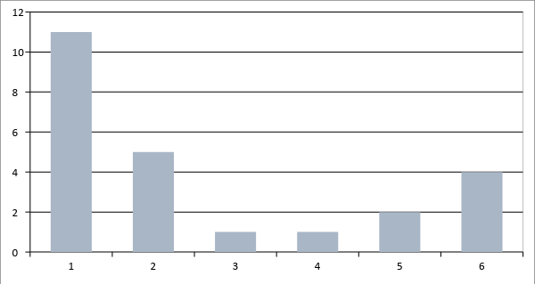

1 | All archaeological archives automatically go to the central (state) repository
2 | All archaeological archives automatically go to the regional (state) repository
3 | The project is within a local museum's collecting area
4 | The documentary archive is always curated at a local records office, the material archive at a museum
5 | The state determines which museum will receive the archive
6 | Other (please specify)
It is usually very clear where curation of an archive will take place and therefore planning for transfer seems quite straightforward. The instances shown here as ‘other’ include cases where universities sometimes collect archives.

  - Survey Section 4: Rationale for Selection
Q 4.1 In most archaeological projects, are the material and documentary products subject to a selection process prior to the compilation of the archive?
Yes | 9 | 37.5%
No | 15 | 62.5%
It would seem that where the state automatically assumes ownership, archive selection is not necessarily a priority, although it can be applied informally during the course of a project, as shown in subsequent answers.

Q 4.2 What are the usual reasons for requiring selection?
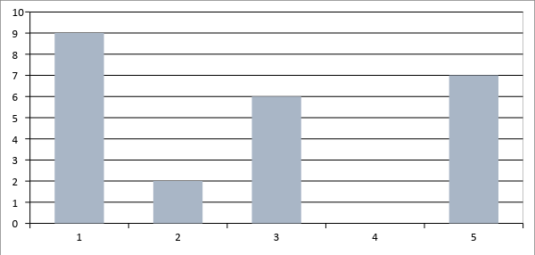

1 | Pressure on storage space at the repository
2 | To minimise the cost of archive transfer and storage
3 | To ensure the academic integrity of the archive
4 | To facilitate access to the archive
5 | Other (please specify)
Although fifteen respondents stated that there is no normal process of selection, most respondents have an understanding of why it might be carried out. Two of the ‘other’ responses state that there is no selection at all, and in the same category are situations where selection is ad hoc, according to the views of the project personnel. The EACWGAA would recommend the following of procedures that ensure selection is designed to ensure the academic integrity of the archive and that only archive components that have the potential to reward future access are deposited for long-term curation.

Q 4.3 How are selection strategies developed?
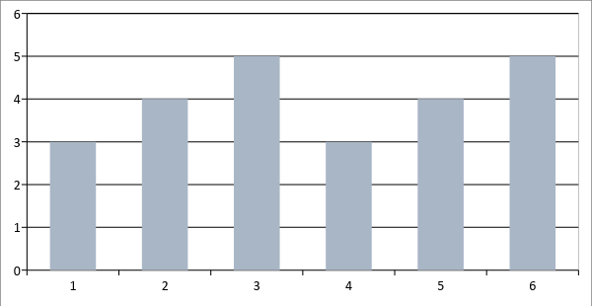

1 | According to a national research framework
2 | According to regional research frameworks
3 | According to local repository collection policies
4 | Field archaeologist
5 | Other (please specify)
6 | Multiple policies and research frameworks
Although research frameworks inform most selection strategies, there are instances where repositories have the final say and also the excavators. Among the ‘other’ responses are those where there is no selection, or there are no real strategies at all.
Interestingly, the above answers match the results of the survey carried out in 2017 by the Making Choices Working Group of the EAC, which revealed that only 4 of the EAC member countries had “a published national framework of scientific or research objectives for archaeological work”. In three further states, there were “some regional frameworks, or ones concerned with particular sites, areas or themes” (Making Choices 2018, 20).

Q 4.4 For each archaeological project, is the selection strategy…
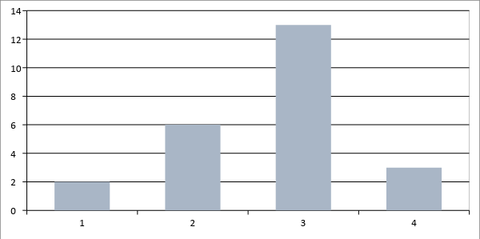

1 | Generic according to national criteria?
2 | Generic according to regional or local criteria?
3 | Individually tailored to the research aims of every project?
4 | Other (please specify)
The EACWGAA recommends that selection strategies are designed to meet the specific aims and objectives of each individual project (Perrin et al. 2014, 25) and that is what is mostly shown here. It may be risky to stick to generic criteria because fieldwork will throw up unexpected discoveries that may require an amendment to the strategy. All the same, those will provide a good starting point, as long as, from the outset, the strategy can be adjusted to the needs of an individual project and amended as it progresses.

Q 4.5 Who has been involved in developing national criteria for selection?
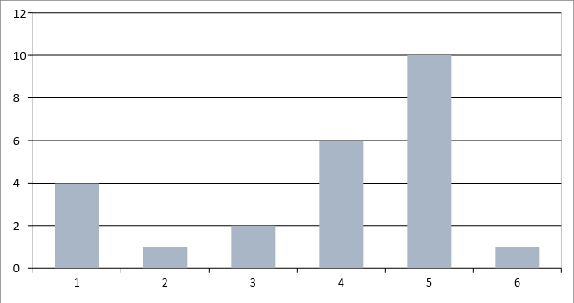

1 | State heritage board / service
2 | National association of archaeologists (or equivalent)
3 | National or regional body for museum archaeology
4 | Multiple agencies
5 | There are no national criteria
6 | Other (please specify)
It is perhaps encouraging to see that where there are national criteria for selection, in several cases multiple agencies are involved in developing them. There is no obvious pattern however, and this may reflect how selection is not built into archive planning from the outset.

Q 4.6 Is there a definition for ‘selection’ in place in your country/region/system?
Yes | 3 | 12.5%
No | 21 | 87.5%
Although various reasons for selection and various frameworks for carrying out are indicated in the answers given above, in very few instances is the process defined. This may be an important indicator of how random the process can be and how little the importance of regulating it might be understood.

  - Survey Section 5: Selection Methodology
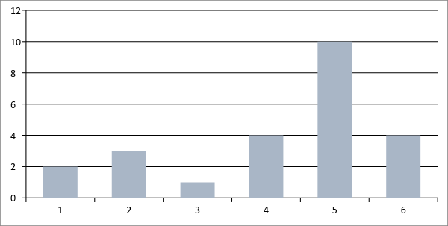
Q 5.1 Who specifies that a selection strategy has to be developed for a project?

1 | The project executive
2 | The project manager
3 | Regional board
4 | State heritage board / service
5 | Multiple project stakeholders
6 | A selection strategy is not developed
There seems to be no clear and obvious pathway towards the development and implementation of a selection strategy. In only three instances is the Archaeological Repository involved, together with other project personnel, in specifying selection. Among the multiple stakeholders a combination of the project executive and the project manager is most common, so this mainly seems to be a project management function, rather than related to collecting the archive.

Q 5.2 When is the strategy for selection developed?
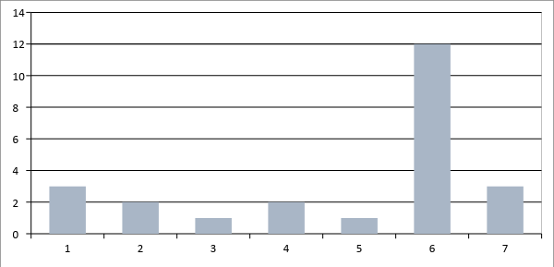

1 | Project planning
2 | Data-gathering
3 | Assessment / analysis
4 | Archive compilation
5 | At the repository after archive transfer
6 | Multiple project stages
7 | There is no selection
The EACWGAA considers the selection strategy to be something that develops throughout the course of a project but it should be introduced in the project planning phase (Perrin et al. 2014, 25). That is the case in thirteen of the answers here, although there is still wide variation across all project stages.

Q 5.3 Where is the selection strategy documented?
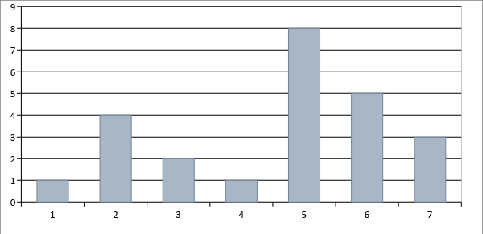

1 | In the project brief
2 | In the project design
3 | In the post-excavation design
4 | In the criteria for transferring the archive to the repository
5 | In the project report
6 | It is not recorded
7 | Other (please specify)
If a selection strategy has been introduced it is important that it is fully documented, and that the de-selected material can be identified. Strategies that are documented only in the project brief or design will not necessarily show any amendments that were made as the project progressed, so in most cases it would usually be preferable to document the selection strategy from the post-excavation design stage onwards. Publication in the project report is the most common approach here but ideally it would also be included in the archive as a separate document, to accompany any further analysis of the data and finds. Under ‘other’ is the requirement for the repository to document the selection strategy, either in their deposition requirements, or after archive transfer.

Q 5.4 Who is involved in developing the selection strategy?
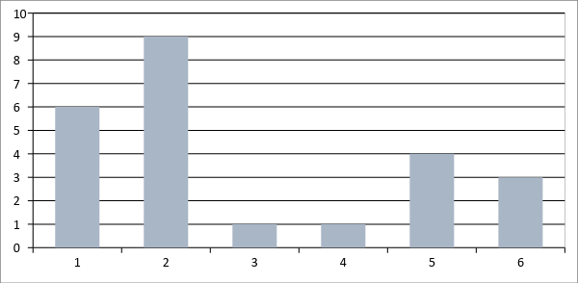

1 | The project executive
2 | The project manager
3 | Finds specialists
4 | Digital archive specialists
5 | Multiple project personnel
6 | Selection does not take place
The responses to this question show that the responsibility for creating and developing the selection strategy lies mainly with project management personnel. In only two instances, included in answer five, are repository curators involved. In answer five, finds specialists are mentioned three times, alongside other personnel. The recommendation of the EACWGAA is that project managers, specialists and repository curators should all be involved in agreeing and developing the selection strategy because all of them have different perspectives on the importance of specific archive components (Perrin et al. 2014, 25).

Q 5.5 Who implements selection procedures?
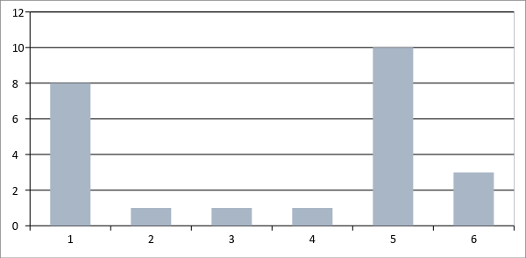

1 | Project manager
2 | Finds specialists
3 | Archive compiler
4 | Repository curator
5 | Multiple project personnel
6 | Selection is not carried out
It seems that the selection of archive components is considered to be mainly a task for the project manager, who is included in all ten of answer five, as well as the eight shown as answer one. Finds specialists are mentioned ten times in total, between answers two and five, archive compilers only once and repository curators four times. It is interesting that the responsibility is given so often to finds specialists because it is not always the case that they have the means to dispose of de-selected material. This question could be researched again in more detail.

Q 5.6 Who is involved in amending the selection strategy if the project changes as a result of unexpected discoveries?
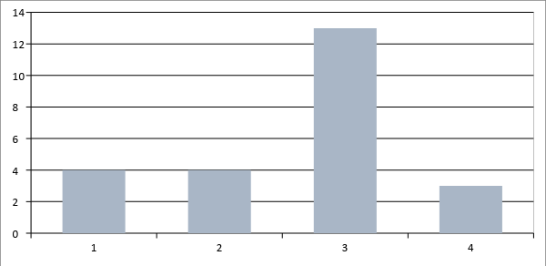

1 | The project executive
2 | The project manager
3 | Multiple project personnel
4 | Selection is not carried out
In most cases multiple personnel are involved in amendments to the selection strategy. Within answer three, repository curators are mentioned four times, finds specialists seven times and public heritage boards twice. The project executive is mentioned fourteen times in total and the project manager seventeen times and this conforms with the EACWGAA view that this is a project management responsibility, in consultation with other personnel as appropriate (Perrin et al. 2014, 31, 33).

Q 5.7 Who ensures that selection has been carried out in accordance with the selection strategy?
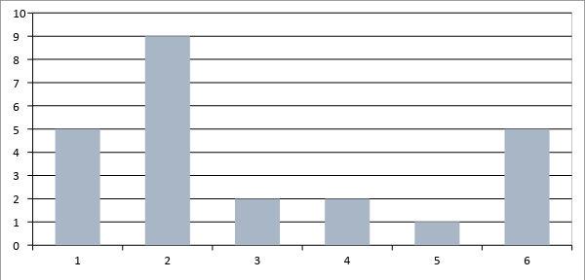

1 | The project executive
2 | The project manager
3 | Project archive manager
4 | Museum curator / collections staff
5 | Multiple project personnel
6 | Selection is not carried out
As with most of the other answers in Section Five, the task of monitoring the application of the selection strategy lies mainly with project management personnel. The EACWGAA considers that the involvement of the repository is equally important (Perrin et al. 2014, 25, 33) but that is represented twice only in the answers given here.

Q 5.8 What is your definition of ‘selection’?
There is a lot of variety in the answers given here. Some are obviously given from a personal perspective, while others are seemingly based on official policy or the EAC Standard, which is given as ‘the procedure for selecting archive components for inclusion in an archaeological archive intended for long term storage’ (Perrin et al. 2014, 53). That now seems somewhat simplistic and one recommendation from this survey could be the drafting of a more comprehensive definition of selection and a full description of the selection process.
The answers to Question 5.8 are listed here.
Assessment of the scientific and historical significance
A process of assessing the working project archive (all data and materials gathered during the course of a project) to establish which items or elements will be selected for curation in perpetuity in order to establish the significance of the project and support future research, outreach, engagement, display and learning activities.
Deciding what will be transferred
Eliminating unwanted objects and/or documents after fieldwork; applies to material with no apparent information value.
Not all the archaeological finds are kept; Parts of it are possibly documented and rejected or even eliminated without documentation (in the case of missing resources).
Non-archaeological material and indeterminable atypical finds could be selected, digital photo-documentation (duplicate and poor quality shots)
Our definition of selection is based on the guidelines of the state Service for archaeological heritage.
Scientifically relevant
Selection can be which finds you collect and which you don´t collect. Selection can also be sorting out finds which you have collected. The reason for this can be that the find is in a bad condition or does not contribute to the understanding of the site.
Selection depends on the finds, sampling only when necessary
Selection is a documented process of discarding archaeological evidence regarding specific needs (academic, practical, economical) in order to optimise composition of the resulting archaeological archive.
Selection is assessing which materials will give the maximum amount of knowledge and which have given no added information
Selection is whether or not to retain an object or dispose of it.
Selection of finds to be collected during the field work supported by technical and scientific principles
Something which has been chosen
The main principle is to collect all the material that is made by human or describes the human activity, but selection is the normal process during the archaeological excavation. It is important to pick up all possible artefacts and ecofacts from older and untouched layers. The younger (historical time, industrial time) layers and mixed layers contains a lot of mass material and in the cases is aim to collect all the artefacts which describes best the particular layer and left beside mass material (for example it is important to collect rim- or base sherds but it is understandable if there will be left indeterminable small pieces).
The one from "The Standard and Guide..."
There is as yet little thinking on possible "meanings" of or for selection in our system. Some preliminary thinking has been done about choosing what to excavate - i.e. the 1000th Roman Villa or the 20th medieval watermill. Where is the return on "the amount of new knowledge gained" likely to be best? But there is no thinking on selection of material produced by Projects once they are underway
What is delivered to the National Museum and what is discarded
When a certain category or type of finds are removed from the collection. Also when only a representative part of finds are archived.
When archaeologists decide what kind of documentation to submit and what not. The compulsory part (which is quite a lot and detailed) has to be submitted, but apart from these several other documentations are being made but these very rarely get submitted.

Q 5.9 With regard to de-selected finds: are regulations/procedures in place for disposal, e.g. avoiding site contamination, or for the treatment of human remains?
Yes | 8 | 33%
No | 16 | 67%
Some of the answers to this question are accompanied by qualifying remarks, one of which mentions destruction of de-selected finds, while another speaks of re-burial on site. Others mention standards for dealing with human remains but nothing else. It is clear that in the majority of cases, how to deal with de-selected material has not been seriously considered and there is a clear need for the development of guidance, if not a standard, for the disposal of de-selected material and the recording thereof.

Q 5.10 Are discarded items documented?
In the majority of cases there is some documentation of de-selected material but there is little consistency in how that is approached. It could be argued that deselected finds should be recorded to as high a standard as possible before they are disposed of but it seems that is rarely achieved.
Yes | 14 | 70%
Sometimes | 2 | 10%
No | 4 | 20%
If so, how?
Appendix list
Discards are listed in an Excel sheet and this documentation is part of the site documentation.
In the excavation report
In the same manner as the catalogued finds with addition of photographic documentation.
Individual decision
It depends on the project manager- all the items must be documented and the report must contain information about where they left
Material objects will be recorded in the finds recording process; early version or duplicate digital files will probably not be documented.
Mostly archaeologists take a picture of the artefacts that they don’t include in the collection, and/or describe literally the discarded artefacts in the report
Noted in database. For some find categories, the discarded items are weighed, counted and photographed (for example roman tile fragments)
On site: through assessment. In a later stage (or repository): everything must first be registered and studied before it can possibly be discarded
Partially. Written and photographic record
Photography and description of discarded items added to general description of the objects collection of a given site
The remains are documented in the project archive. And museums should document the de-accessions in their inventories.
The weight is recorded and a photographic documentation is done
They should always be registered in the list over collected finds
No general rule can be described.

  - Survey Section 6: Sustainability
Q 6.1 Has there been research into the results of selection?
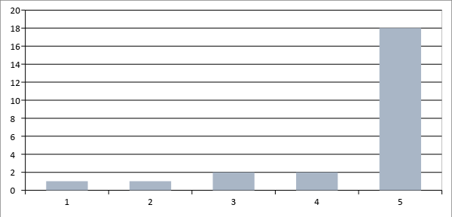

1 | Quantifying the volume of archives deposited in years prior to developing selection process
2 | Quantifying the volume of archives deposited in years after developing selection process
3 | Measuring the numbers of research enquiries of project archives
4 | Other (please specify)
5 | No

For many respondents, the issue of selection is relatively new and research has yet to be commenced. Where there has been some research, a varied approach is apparent. One response, for instance, mentions research into metal finds and the cost of conservation, which is a very focussed, if potentially informative, line of enquiry. There is as yet no recommended way of evaluating the success of selection procedures but if one of the main drivers is to reduce the amount going into repositories, then quantifying by volume would seem to be the most useful approach.

  - Survey Final Section: Comments
Do you have any remarks about the questionnaire or the selection process in your country?
In our country, the selection process is not completely arranged
In our country this is not at the moment so critical a question as in other countries because there are so few large archaeological field works
It is not yet properly organised. At the moment it is all somewhat ad hoc, so selection is not very well controlled and curators are not always consulted. There are guidelines and standards (including ARCHES) but few practitioners have yet produced a selection strategy as part of project planning. A new Selection Toolkit has now been produced and this will guide people through the selection process from project planning to archive transfer.
More cooperation between the different countries to discuss and obtain some international selection procedures to be implemented by all.
Problems of selection have no general shape in our country and it is based in common research practice. Intentional selection is usually not applied in the projects, but the selection process is more driven by selected project methodology (in general) and by the academic specialisation of a leading researcher.
There is an obvious need for a general code of conduct based on research and evaluation.
There is no official document in our country on the standards for the selection of archaeological finds and documentation. The legal framework is the Act on the Protection of the Monuments and Historic Sites and the relevant decree defining the archaeological findings and the requirements of archaeological research documentation. Within this framework, project managers and/or executives decide what findings and documentation are important and useful for their research aims.
We are still in the first stages of creating procedures for the selection of certain archaeological materials.
We have realized that due to the growth of the amount of archaeologists and because of the rescue excavation carried out in historic towns, there is a need for guidelines (or demands or agreements) for the archaeologists, museums and heritage board about selection principles. Of course, in case of archaeology, there are so many uncertainties and irregularities and therefore guidelines have to be flexible, but in main principles it is possible to find an agreement.

- Bibliography
Boyle G., Booth N., Rawden A. 2016, Museums Collecting Archaeology (England) REPORT YEAR 1: November 2016, Society for Museum Archaeology.
Boyle G., Booth N., Rawden A. 2017, Museums Collecting Archaeology (England) REPORT YEAR 2: November 2017, Society for Museum Archaeology.
Boyle G., Booth N., Rawden A. 2018, Museums Collecting Archaeology (England) REPORT YEAR 3: November 2018, Society for Museum Archaeology.
Making Choices 2018: Valletta, Development, Archaeology and Society. A Report of the ‘Making Choices’ Working Group of the Europae Archaeologiae Consilium.
Perrin K. et al 2014, A Standard and Guide to Best Practice in Archaeological Archiving in Europe, EAC Guidelines 1.

