Making Choices for Archaeological Archives
Appendix
Report on archaeological selection procedures in Poland – a case study

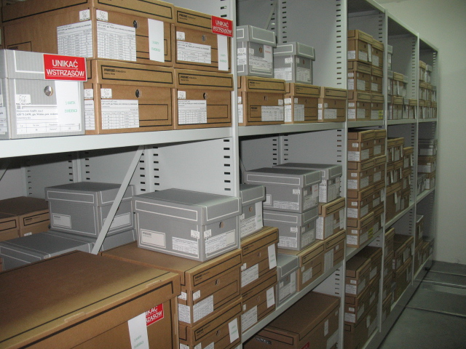

Agnieszka Oniszczuk
EAC Working Group for Archaeological Archives
Contents
- Storage of archaeological finds in Poland 3
  - Laws and regulations 3
  - Implementation of legal provisions 4
- Participation in the survey 6

  - Target group 6
  - Actual respondents 7
- Analysis of the answers 7

  - Ownership of archaeological material (q. 1.1-1.3) 7
  - Copyright to documentary archive (q. 2.1) 8
  - Curation of various elements of archaeological archives (qq. 3.1-3.5) 9
  - Selection – general issues (q. 4.1-4.6) 12
  - Selection strategy (qq. 5.1-5.7, 5.9, 5.10) 13
  - Respondents’ definition of selection (q. 5.8) 14
  - Research into the results of selection 15
  - Final remarks 15
- Summary 16
- Bibliography 17

- Storage of archaeological finds in Poland
  - Laws and regulations
System of archaeological heritage protection in Poland is shaped by the Act of 23 July 2003 on the protection and guardianship of monuments. It defines, among others, a monument and an archaeological monument and differentiates between administrative actions of monuments protection from the guardianship carried out by owners of monuments. Moreover, accompanied by several ordinances, it regulates issues of various forms of legal protection, archaeological research, financing, and organisation of state monuments protection services, specifying the roles of individual actors.
With regard to this report, the most important regulations are summarised below.
Archaeological objects are legally defined as immovable monuments constituting surface, underground or underwater remains of human existence or activity, composed of cultural layers and works or traces thereof contained in these layers, or movable monuments constituting such works. However, in order to be defined as archaeological, first they have to meet the general definition of a monument, which means they have to be worthy of preservation for their historical, artistic or scientific value. This implies the possibility of selection, however, the notion itself does not appear in any legal acts.
Archaeological objects belong to the State, and are subject to protection regardless of their state of preservation. They can be permanently stored in museums or “other organisational units”, private or public, that ensure their permanent curation, cataloguing, and conservation, as well as accessibility for scientific purposes.
A permit from provincial heritage service (namely, the Voivodeship Monuments Protection Officer) is required to carry out any archaeological fieldwork. Any applicant, be it a person or an institution (researcher, landowner, developer), has to submit a series of documents including a written consent of a museum or other organisational unit to accept future finds.
Permanent storage place for the documentary and material archives is specified individually for each project in the permit to carry out archaeological research. Within 3 years from completing the fieldwork, the documentary part, including the scientific study of results, goes to the archives of the respective Voivodeship Monuments Protection Office and the finds (after inventorying and conservation) are transferred to the appointed museum or unit. According to the law the latter should happen via the Voivodeship Monuments Protection Office, by way of an administrative deposit decision issued with a consent of the institution in question. Upon an application of the Director of this facility, the ownership of the deposited finds may be transferred to this facility by an administrative decision of the Voivodeship Monuments Protection Officer.
The permanent storage facility is responsible, also financially, for further curation of its new collection. All the museum objects have to be catalogued in a way that allows the identification of individual pieces (e.g. pottery shards) by preparing inventory sheets for all the items and entering them in the museum inventory or the deposit book, depending on the ownership status.
Relevant legal acts (available at www.isap.sejm.gov.pl)
System of heritage protection: Ustawa z dnia 23 lipca 2003 r. o ochronie zabytków i opiece nad zabytkami (consolidated text Dz. U. 2018, item 2067)
Archaeological research: Rozporządzenie Ministra Kultury i Dziedzictwa Narodowego z dnia 2 sierpnia 2018 r. w sprawie prowadzenia prac konserwatorskich, prac restauratorskich i badań konserwatorskich przy zabytku wpisanym do rejestru zabytków albo na Listę Skarbów Dziedzictwa oraz robót budowlanych, badań architektonicznych i innych działań przy zabytku wpisanym do rejestru zabytków, a także badań archeologicznych i poszukiwań zabytków (consolidated text Dz. U. 2018, item 1609).
Museums: Ustawa z dnia 21 listopada 1996 r. o muzeach (consolidated text Dz. U. 2018, item 720)
Inventorying finds in museums: Rozporządzenie Ministra Kultury z dnia 30 sierpnia 2004 r.
w sprawie zakresu, form i sposobu ewidencjonowania zabytków w muzeach (Dz. U. 2004, vol. 202, item 2073).

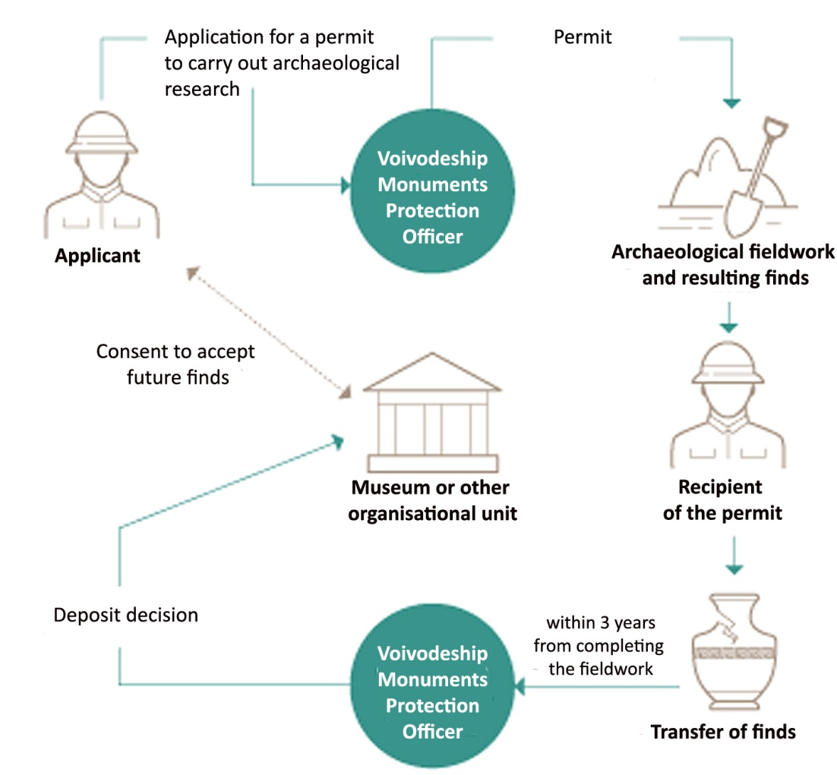
Fig. 1 The “life cycle” of archaeological material archives in Poland, based on the Information on results of the audit…, p. 9, infographics no 2.
  - Implementation of legal provisions
Heritage professionals in Poland have long realised that the functioning of the described system is not perfect and that the implementation of legal provisions leaves at least something, if not much, to be desired. Hard data on the subject were brought to light after an audit carried out in 2017 by the Supreme Audit Office (PL abbrev. NIK), the main independent state audit body whose mission is to safeguard public spending. The audit entitled “Protection of archaeological objects discovered in relation to construction investments” was carried out in 8 (out of 16) Voivodeship Monuments Protection Offices, 15 museums, and 2 municipal centres for culture storing archaeological objects (Supreme Audit Office 2018, 59, 86).
It was established that the actions taken by the Voivodeship Monuments Protection Officers were not effective in assuring proper protection of archaeological objects collected during development-led archaeological research (Supreme Audit Office 2018, 14). The obligations concerning the deadlines for presenting various elements of the documentary and material archive were not enforced on the researchers (Supreme Audit Office 2018, 14, 17, 40-44). Most of the controlled offices did not check whether museums or other units accepting finds ensure proper storage conditions (Supreme Audit Office 2018, 14, 17, 57-58). Also, they did not have full knowledge about the time and place of discovery of archaeological objects, their exact number, the place of permanent storage, and the way of transferring the archive, which was obviously contrary to the law (Supreme Audit Office 2018, 14, 17, 44-46). In only 33% of the analysed cases there were official documents regarding the acceptance of material archives by museums, which means that in the remaining 2/3 the officials were not able to say when and if the archives had been accepted for permanent storage (Supreme Audit Office 2018, 14, 17, 46-48).
This grim picture was reflected also at the other end of this archaeological chain. 60% of the museums accepted archaeological objects directly from researchers or archaeological companies without an obligatory deposit decision from the respective heritage service. Such an unregulated state of the archives could have lasted even up to 10 years. During that time the objects were not catalogued; they were also not reported in the official statistical data (Supreme Audit Office 2018, 18, 59-62). In more than a half of the audited museums there was no proper documentation of admissions, and representatives of the Voivodeship Monuments Protection Offices hardly ever participated in admissions of new collections. Several museums stored the material archives without their documentary counterpart (Supreme Audit Office 2018, 18-19, 62-64). There were deficiencies in cataloguing the accepted finds. 30% of the museums did not register material archives in their deposit books, replacing this obligation with registering deposit decisions, thus, getting 1 entry instead of thousands. In 2/3 of these institutions inventory sheets were not made for bulk finds, other 2 demanded the sheets from archaeological companies upon admission of the archive (Supreme Audit Office 2018, 19, 65-67). Again, both these practices, although resulting from maladjustment of binding regulations to cataloguing mass archaeological finds, are against the law. Resulting from the above, over 50% of the museums did not know the exact number of stored objects. In only 1 case the official statistical data were consistent with the actual state and the museum inventory (Supreme Audit Office 2018, 19, 67-69). In 88% of the museums storage conditions for archaeological objects were not controlled by the state heritage service nor by the museum organisers, i.e. local authorities (Supreme Audit Office 2018, 20, 76-77).
On the other hand, almost all the museums collected archaeological objects according to their statutes, as it should be done according to the law, and had qualified staff. They also reported significant issues related to storage and conservation costs of archaeological objects belonging to the State, pointing out that the owner’s participation in their curation was insufficient (Supreme Audit Office 2018, 13). Most of the museums had professional storage spaces. Only 2 had no capacity for accepting new archaeological finds (Supreme Audit Office 2018, 20, 78-81).
It should be noted here that in Poland there are no specialised archaeological museums run on a national level; they are usually financed by various level of local state administration or self-government. At the moment the Ministry of Culture and National Heritage is considering various options for creating the network of archaeological storage facilities throughout the country.
- Participation in the survey
  - Target group (Fig. 2)
As initially assumed, the questionnaire was sent out by the National Heritage Board of Poland to: museums storing archaeological objects (22), 2 archaeological storage facilities, 1 university institute of archaeology, and 1 professional association. The total of 26 invitations to participate in the survey were sent.
Those museums were either specialised archaeological museums, sometimes of more than a hundred years of tradition, or museums with archaeology departments, i.e. institutions employing specialised personnel and, hopefully, having proper facilities. The choice was based on the profile of these institutions, and was limited to the usually responsive ones. The scale and significance of respective museums will be analysed below with regard to the respondents.
Two of several archaeological storage facilities (see: Bugaj 2018) considered Polish examples of best practice were contacted. One is affiliated with a local museum, another with the Institute of Archaeology at a local university; they are specialised institutions with adequate staff and equipment.
One university institute chosen for filling the questionnaire was treated just as an example, a representative of similar entities dealing with archaeological storage on a daily basis without fully developed storage sections in terms of personnel, equipment, and strategies.
Moreover, to widen the recipient base, a major archaeological association in Poland was chosen as it brings together archaeologists from various parts of the sector: commercial archaeology, museums, and academia.
The invitation letter in Polish was accompanied, were necessary, by a Polish translation of the questionnaire done by the Author. In order to limit language issues, the translation included a reference to the Polish version of “Standard and Guide to Best Practice for Archaeological Archiving in Europe” (Perrin et al. 2014) and clarification of various terms from the questionnaire not commonly used in Polish.

Fig. 2 Structure of the desired target group
  - Actual respondents
The response was 44%. We received answers from 11 institutions: 1 archaeological storage facility, 1 university, and 9 museums. 4 of the latter can be considered large, based on their seat and significance for archaeology, or, generally, for culture. This category comprises 2 provincial museum and two specialised archaeological ones. The remaining 5 are smaller, local institutions. Regardless whether they are seated in towns or in cities they focus on their immediate vicinity (region, or city) and their activities are locally oriented.
Comparing to the desired structure of the respondent group, the input from local museums turned out to be smaller (45.5 instead of 53.8%) and the impact of large museum – greater (36.4 instead of 30.8%) than expected. As for individual institutions, the answers from large long-established archaeological museums, museums seated in large cities, and another storage facility are sorely lacking.
The answers came from 7 out of 16 voivodeships (provinces) – 6 less than expected, which also hampers the conclusiveness of the results. Nevertheless, they illustrate some general tendencies in archaeological storage in Poland.
5 questionnaires were filled online. 6 respondents filled the Polish-language version. Their answers were then translated into English and entered in the online form.
There was one more answer from Poland formulated by the National Heritage Board, Polish representative in the EAC, defining legal system and storage situation and issues in the national scale, and – as being on a different level of generality – it is not analysed in this report.
- Analysis of the answers
  - Ownership of archaeological material (q. 1.1-1.3)
Almost all the respondents said that all archaeological objects are automatically owned by the State and transferred to a selected repository (q. 1.1). One of them described the entire legal procedure (see: p. 1-2 of this report), i.e. agreed with the rest of the respondents.
7 of them (64%) had no opinion on when the transfer of title is agreed (q. 1.2). Of the remaining 4, one chose the data-gathering phase, another the project planning – meaning the moment of applying for and getting a permit for research. The last two considered rather signing off the title, as they referred to deposit decisions issued by the Voivodeship Monuments Protection Officer. One of them repeated this answer in the next question.
Together with the answers mentioned above, there were 4 answers to the question on signing off the title. One chose the “point of the archive transfer, and the other three, generally, referred to the procedure of obtaining the deposit decision. Two of them mentioned applying for ownership (see: p.1)
  - Copyright to documentary archive (q. 2.1)
Question on the copyright to documentary archives brought the variety of answers (Fig. 3) Below we are considering 12 answers, because one of the respondents has chosen 2 options.

Fig. 3 Answers to question 2.1
According to 3 answers the copyright to documentary archive is never considered. Another 2 respondents do not consider copyrights; one of them provided additional explanation of the functioning system to which the copyright does seem irrelevant – in the Act of 23 July 2003 on the guardianship and protection of monuments nor the related regulations there is not a single mention of this issue, although there are separate regulation on that matter in Polish legal system. Yet 3 more answers reflect the reality, stating that the issue of copyrights is not resolved. These answers add up to 66% of the total. In the remaining 4 answer the issue has been resolved by: creators issuing the licence to the repository (2) or transferring all copyright to the repository (2). In the case of the latter the regulation of the copyright issue is only apparent, as this answer is accompanied by a completely opposite option of not considering the copyright at all.
  - Curation of various elements of archaeological archives (qq. 3.1-3.5)
Analysis of 10 answers regarding the place of curation of the documentary archive (q. 3.1) required prior clustering as several respondents had not assigned their answer to categories listed in the questionnaire or assigned the same answer to different categories (the exact answers were given in the comments). With that in mind, the distribution of answers adjusted to the exact ones is illustrated below (Fig. 4).

Fig. 4 Answers to question 3.1
In the questionnaire, local branch of the heritage service, namely, the Voivodeship Monuments Protection Office was referred to as a “regional (state) archaeology repository” or a “regional (state) documentary archive”. “Unit curating the corresponding material archive” was referred to in the questionnaire as a museum, always specified in the comments. The category of “creator” listed above was created by interpretation of the answers; it was an archaeological field unit, a museum or university. It has to be emphasised at this point, that in Poland it is a legal obligation to transfer some elements of the documentary archive (specified in the permit) only to the local branch of the heritage service. Obtaining a copy by a storage facility of any kind, although necessary from the methodological point of view, is not legally required, which is why, the option of creator or creator/curator of the material archives appeared in 4 answers.
Asked for the storage place for the digital archives (q. 3.2), the respondents gave the total of 15 individual answers (multiple choice question).

Fig. 5 Answers to question 3.2
6 answers pointed at a museum or archaeological repository, 4 at a regional (state) documentary archive facility. The latter can be read as the archives of the respective Voivodeship Monuments Protection Office or its local delegacy. Another 4 chose, generally speaking, the creator of the archive referred to as an archaeological field unit or, descriptively, as an archaeologist or unit carrying out archaeological research. One respondent, chose a “local, publicly funded, specialised digital archive facility”, which in this particular case meant that museum. Three answers combining several options included: creator, museum, and heritage service (2) and museum and heritage service (1). Distribution of answers reflects the actual situation in which the issue of digital archaeological archives is not legally resolved. Moreover, the prevalent answer shows the unofficial good practice, in which the digital archive goes with the finds.
Analog copies of born digital materials (q. 3.3) were required mostly by museums or archaeological repositories (5 individual answers compared to 2 negative ones). They were usually not made by creators or required by “regional (state) documentary archive facilities”, i.e. the heritage service (3 negative answers compared to 1 positive). The latter is quite surprising because the Voivodeship Monuments Protection Offices are usually perceived as very traditional and “analog”, as only paper documentation is legally required. It may bring an optimistic prognosis for the future. On the other hand, traditionalism of museums and their digital deficiency seems to have been confirmed.
Asked to choose a place of curation of the material archive (q. 3.4), 6 respondents pointed at museums or archaeological repositories, which seems to reflect their everyday practice. In one case the Voivodeship Monuments Protection Officer was chosen, probably to reflect the actual legal status, i.e. the transfer of the finds via the heritage service. Quite surprisingly, one museum chose archaeological field unit. In the remaining 3 answers various options were given, reflecting the general practice: publicly funded local museum or archaeology repository; local, specialised archaeological materials repository; university; archaeological field unit; and privately managed commercial storage facility. In fact, all these options are possible. As one of the respondent indicated, the place of permanent storage is specified individually for each project by the Voivodeship Monuments Protection Officer.
There were 10 answers to the question on the way of determining the repository to collect an archaeological archive (q. 3.5). 2 referred to the legally demanded consent of a storage facility to accept the future finds, and the deposit procedure (see: part 1). One of these respondents said that as a museum they always consider territorial, chronological and thematic scope of the prospective finds that have to be consistent with the Museum's statutes. This remark is valid for all the museums in Poland; their statutes have to specify what they collect. Various combinations in the remaining answers reflect particular situation of every respondent, there are however some general tendencies (Fig. 6).
Fig. 6 Answers to question 3.5
Poland is not divided into local museum’s collecting territories (such answer was chosen by 5 institutions), however this is the common practice especially for regional museums or archaeology-collecting ones that are unique in their locality. 4 answer reflect the issue of separating the documentary archives from the corresponding material ones. 3 institutions noticed the common practice of scientific institutes permanently storing archives from their own research projects. One respondent marked an option of using commercial storage facilities when museum storage is full and one – of leaving the archive in an archaeological field unit for an indefinite period of time. 2 of them indicated the role of the heritage service in specifying the place of permanent storage of each and every archaeological archive.

  - Selection – general issues (q. 4.1-4.6)
Asked for selection prior to the compilation of the archive (q. 4.1), 3 respondents said that it existed, and the rest disagreed. Nevertheless, 2 of the latter answered the remaining questions on selection probably theorising on what might apply if the archives were subject to selection.
Most of the respondents said (4 out of 5) that the selection is to ensure the academic integrity of the archive (q. 4.2). 3 pointed at its economic reasons: pressure on storage space (2) and minimising the cost of archive transfer and storage (1). Answer from an archaeological storage facility included a practical aspect of facilitating access to the archive, and referred to the selection being the decision of researchers rather than repositories.
Variety of answers to the question the way of developing selection strategies (q. 4.3) probably reflects confusion as to the very term of “research framework” (Fig. 7).

Fig. 7 Answers to question 4.3
Surprisingly, in 2 cases selection strategies are developed according to a national research framework and in 1 according to a regional one, however – as was indicated in another answer – there are absolutely no selection strategies on these levels in Poland (there are no research frameworks either). The respondents may have referred to legal regulations instead. Selection strategies may be determined by research objectives of an individual project but also by scope of interest of various storage facilities determined in their statutes. In fact, these are the existing and formulated selection strategies, but museum generally do not seem to realise that.
The above is reflected in answers to the next question (q. 4.4) where selection strategy is mostly described as “individually tailored to the research aims of every project” (4 out of 5). In one case it was defined as “generic according to regional or local criteria”, which, considering other answers from this particular respondent, probably refers to legal regulations on the subject.
In the absence of the national criteria for selection, there is only one substantive answer to q. 4.5. It should be treated as reference to the work in progress or theorising, therefore: the state heritage board and the national association of archaeologists should be involved in developing these criteria.
As expected, according to all the answers there is no definition of selection in Poland (q.4.6).
  - Selection strategy (qq. 5.1-5.7, 5.9, 5.10)
4 answers about the initiators of developing the selection strategy (q. 5.1) do not illustrate any general tendencies. The repository manager (museum curator/collections manager) and state heritage service chosen by the respondent from a specialised archaeological storage facility illustrates the specifics of this institution. The list of actors supplied by another respondent, including: the project executive, the project manager, the repository manager (museum curator/collections manager), state heritage service, resembles the EAC Guidelines 1 according to which: “A selection strategy should be drawn up with input from all the relevant members of the project team, including specialists and the curator of the repository or repositories into which the final archive will be received” (Perrin et al 2014, 25). The remaining two answers were: the project manager and the project executive. It should be noted that the latter was explained in Polish version as the project supervisor, someone above the project manager, e.g. from the heritage service or the developer’s side.
In 4 answers about when the selection strategy is developed (q. 5.2) the total of 11 options were chosen. Their distribution is illustrated below (Fig. 8).

Fig. 8 Answers to question 5.2
It is easily noticed that decisions on selection are mostly made post factum, in the post-excavation phases (over 70%), sometimes probably ad hoc – in the data-gathering phase (for more remarks see: Wiśniewski 2017), and rarely when they should be made – at the planning stage.
Because of the above the selection strategy is documented in the project report (2 answers) or in the criteria for transferring the archive to the repository (q. 5.3).
According to the respondents the party involved in developing the strategy (q. 5.4) can be either: the project executive, the project manager, finds specialists or museum curator/collections staff (4 answers).
It is mostly the project manager who is considered responsible for implementing selection procedures (3 out of 4 answers to q.5.5). In one case finds specialists and repository curator were chosen.
Amending the selection strategy in case of unexpected discoveries (q. 5.6) is a responsibility of the project manager in all 4 answers to the question. In two cases supervisors in the form of the regional heritage service and the project executive were added.
The duty of controlling implementation of the strategy (q. 5.7) is also assigned mostly to the project manager (3 out of 4 answers). In one case museum curator and regional heritage service were chosen. The choice of the former seems quite surprising because he/she is consulted (if at all) before the project begins and sees the finds in detail only after the fieldwork and analysis is completed.
7 answers were given to the question on regulations or procedures regarding decommissioned finds. For respondents said “no”; one of them added an information on their usual practice of re-burial of analysed human remains. 1 answer referred to legal regulations and ethical code without supplying further details, yet another – to the provisions of the Geneva convention, both regarding the treatment of human remains. According the last respondent, his/her museum does not discard the finds but collects them.
According to 3 out of 5 answers the discarded finds were not documented (q. 5.10). In one case they had “due and full” documentation. According to another they were documented only during fieldwork. The last answer presented the entire strategy of studying the collected finds in a museum that does not decommission any archaeological finds. In this institution there has never been a strategy of selecting archaeological objects, but, as we are going to see in a moment, some finds are decommissioned on the regular basis. All “their” objects have been subjected to conservation, scientific study, detailed or at least statistical, and transfer to permanent storage (this museum carries their own fieldworks). They divide objects into categories of the so-called "separated" (with a high cognitive value) and "mass" finds. After anthropological analyses, human remains return to the place of acquisition, e.g. the designated crypts in churches, and in the case of preventive, development-led research they are buried in collective graves at the municipal cemetery, in agreement with the City Hall services.
  - Respondents’ definition of selection (q. 5.8)
Approach to the question about the respondents’ definition of selection deserves separate treatment. None of the respondents referred to the definition given in the EAC Guidelines 1 (Perrin et al 2014, 53). On the contrary, there were 8 different ones. An interesting observation was that the respondents (also in personal contacts) believed that his/her definition was the universal one. To illustrate this variety, resulting from the absence of selection in archaeological discourse in Poland, all the definitions are quoted below.
“It is a process of choosing the artefacts and documentation to be retained at the repository for future study.”
“Deliberate choice of range and methodology of research and documentation, as well as specialised analysis of archaeological objects subordinated to scientific objectives, heritage protection and documentation based on scientific basis, taking also into account possibilities of creation, development and maintenance of archaeological cultural heritage.”
“Elimination of objects, monuments or information that do not meet the criterion of an archaeological monument, object or site.”
“With regard to archaeological sources of my scientific interest the "selection" would be: "harmful action aimed at the elimination of part of the source potential of unknown scientific value".”
„Choice by elimination of acquired archaeological materials that are not monuments or museum exhibits.”
“Choice of the key material without which proper scientific study would be impossible.”
“Separation of archaeological finds of high value for the reconstruction of the historical process, intended for further storage, from worthless or insignificant ones, storage of which is not planned.”
“Selection of archaeological relics from the whole collection obtained during excavations, in order to reduce costs of scientific study, conservation, and storage, considering the cognitive value, state of preservation and repeatability of the finds.”
In case of the lacking answers, the very idea of selection caused some uneasiness, or in one case anger in the respondent. In one of the corresponding final remarks there was a reference to the lack of selection in Polish legal system resulting in collecting all the objects from archaeological sites, which, as known to the Author from the practice of heritage management in Poland, is purely theoretical.
  - Research into the results of selection
There was no reference to any research on the results of selection, which was to be expected, considering the legal regulations.
One respondent described the present situation from his/her institution where the “positive selection” aiming at standardisation of selection strategy was replaced the “negative” one meaning suspending all new accessions. The latter was enforced by filling up the available storage space.
  - Final remarks
4 substantive final remarks were received. One, coming from a specialised archaeological storage facility, pointed at the pressing need for implementation of a national strategy by all the parties involved in archaeological research in order to overcome the chaos caused by the present lack of regulations, which is not beneficial for storage facilities and the archives themselves. The other three referred to the very notion of “selection” as non-existent, being against the law, “not understandable”, “unambiguous”, and “unjustified in the research process”. In none of these has the respondent’s definition of “selection” been formulated earlier.

- Summary
First and foremost, the respondents generally know legal regulations regarding archaeological finds but, as the quoted audit has revealed, they are sometimes forced to make their way round it because of maladjustment of the law to long-term storage of archaeological finds. Their answers reflect profiles of respective institutions; at some points the university and the archaeological storage facility can be easily told from the museums.
Guidance is needed on the most welcome strategy of resolving copyright issues with regard to various elements of archaeological archives, specifically on when and how it should be regulated with regard to the entire archaeological project, because the heritage law in Poland does not refer to proper regulations.
There should also be clear guidance on the preferred place of long-term curation of all elements of the archive, especially focusing on storing its documentary part with the material ones. Regardless from actual financial and organisational possibilities of the actors concerned, the future guidelines must address the issue of digital archiving, emphasising the best possible solution. In Poland its straightforward implementation will not always be possible without changes of legal provisions resulting in giving equal status to paper and born digital documentation.
This questionnaire reflects the lack of discussion on selection in archaeology and the pressing need for it. Even those who accept collections only from their own regions or epochs in the scope of interest of their institutions have distanced themselves from selection. In some cases the selection-related questions caused uneasiness or anger. Needless to say that 8 different definitions of selection were given and each was considered universal. Nevertheless there is a good basis for discussion because academic integrity of the archive and not economic factors were marked as the main reasons for selection of archaeological materials. In the future guidelines the term “selection” should be made clear (again) and the relevant strategies should be explained in detail with actual propositions and emphasis on formulating them in writing at the planning stage of each archaeological project.
The lack and need for selection strategies, preferably on higher levels (regional, national) were also revealed. In Poland they must concern only the stages prior to the transfer to long-term storage because museums can decommission objects only in special cases.
On the national level, guidance is needed from the Ministry of Culture and National Heritage on the implementation of existing legal provisions concerning storage of archaeological finds by all the interested parties.

- Bibliography
Bugaj M. 2018. Magazyny archeologiczne w Polsce – kwestia przechowywania zabytków archeologicznych, czyli rzecz o stajniach Augiasza I kilka przykładów dobrych praktyk/Archaeological warehouses in Poland – the issue of storing archaeological monuments, that is about the Augeas’ stables and several examples of good practices, Raport 13: 160-169.
Perrin K. et al. 2014. Standard and Guide to Best Practice for Archaeological Archiving in Europe. EAC Guidelines 1. https://www.europae-archaeologiae-consilium.org/eac-guidlines [access: 22/01/2019]
Supreme Audit Office, Regional Branch in Kielce. 2018. Informacja o wynikach kontroli “Ochrona zabytków archeologicznych odkrytych w związku z realizacją inwestycji budowlanych” [EN: Information on results of the audit “Protection of archaeological objects discovered in relation to construction investments”].
Wiśniewski M. 2017. Selection of mass finds in archaeological research – assumptions and heritage inspector’s comments on the topic. Ochrona Zabytków LXX: 2 (271): 155-174.

